Week 5

* More notes on understanding Real Time Operating Systems
  + Real Time operating systems concepts
    - <https://www.youtube.com/watch?v=Oe9WzYjKYQg>
    - Preemptions
      * A high priority task can preempt a low priority task, meaning that a high priority task pauses a low priority task so that is can take up CPU resources
      * This is necessary for Real time systems to that essential tasks
    - Scheduler
      * A scheduler maintains a ranked lists of tasks based on priority
      * This ranked ist is used used to enforce which tasks are allowed to perform their job
      * Real time systems have a Priority Based Preemptive Scheduling Scheme
  + RTOS Tutorial (1/5) : Why is RTOS required?
    - <https://www.youtube.com/watch?v=ECEvUEkSSLg>
    - 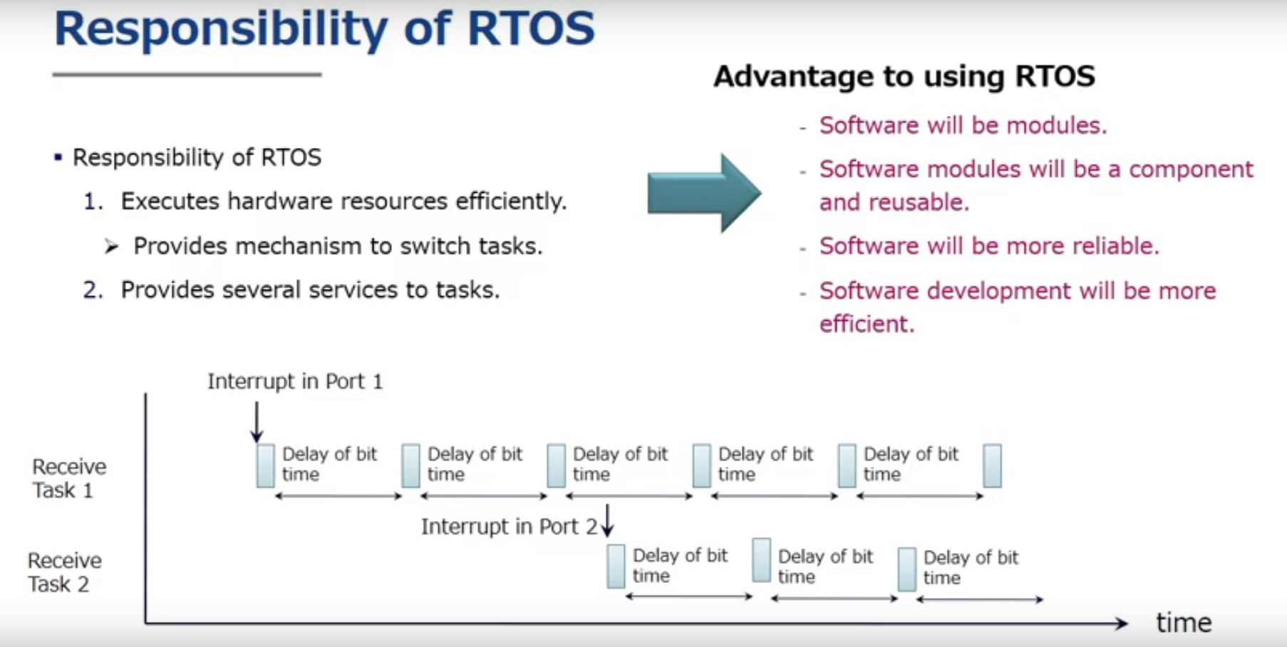
* What I specifically downloaded to configure xenomai (all this should be downloaded under the xenomai_code folder)
  + This is the summary from the info on page (<https://gitlab.denx.de/Xenomai/xenomai/-/wikis/Getting_The_I_Pipe_Patch>)
    - Go to <https://gitlab.denx.de/Xenomai/ipipe/-/tree/ipipe-4.4.y>
      * Make sure you are on the ipipe-4.4.y branch (use the drop down feature found on the top of the webpage)
      * Clone that branch
  + Go to <https://mirrors.edge.kernel.org/pub/linux/kernel/v4.x/>
    - Look for ‘ ipipe-core-4.4.182-x86-15.patch ‘
    - Open up a command line terminal and type in the command
      * wget <https://xenomai.org/downloads/ipipe/v4.x/x86/ipipe-core-4.4.182-x86-15.patch>
  + Go to <https://mirrors.edge.kernel.org/pub/linux/kernel/v4.x/>
    - Click on ‘ Linux-4.4.182.tar.gz ‘ to download that linux kernel
    - Extract the folder and move the extracted folder to the ‘xenomai_code’ directory
* Instruction to prepare Cobalt kernel
  + xenomai/scripts/prepare-kernel.sh --linux=/home/roman/Documents/courses/cs263/RTOS4ROBOTS/xenomai_code/linux-4.4.182 --ipipe=/home/roman/Documents/courses/cs263/RTOS4ROBOTS/xenomai_code/ipipe-core-4.4.182-x86-15.patch --arch=x86_64
* The link below is to help understand what the linux command, uname --help , returns. It may help find which target architecture (--arch= ) you need to enter
  + <https://unix.stackexchange.com/questions/47020/difference-between-machine-hardware-processor-type-and-hardware-platform>